Business Plan for Grandparents Hub
An Online Community & Guided Shopping Platform for Seniors

1. Executive Summary
Company Name: Grandparents Hub
Mission: Empower grandparents with a supportive online community and guided shopping services to enhance their digital independence and purchasing confidence.
Revenue Model:
- Tiered Subscriptions (Basic, Silver, Gold)
- Affiliate commissions from partnered retailers
- Brand partnerships & sponsored content
Key Features:
- Community Forums: Social interaction, advice sharing, and activity groups.
- Guided Shopping: Step-by-step purchasing assistance, product recommendations, and exclusive discounts.
- Tiered Membership: Customizable plans to suit varying needs and budgets.
Vision: Become the leading digital platform for seniors seeking community, education, and seamless online shopping experiences.

2. Market Analysis
Target Audience:
- Grandparents aged 60+ with disposable income.
- Children/family members seeking tech solutions for elderly parents.
Market Trends:
- Aging global population (1 in 6 people will be over 65 by 2050).
- Rising e-commerce adoption among seniors (55% of U.S. seniors shop online).
- Demand for senior-focused tech education.
Competitors:
- Direct: Stitch.net (social community), Senior Planet (tech education).
- Indirect: Amazon’s “Alexa for Seniors,” retail senior discount programs.
Opportunity: Bridge the gap between social connectivity and assisted e-commerce for seniors.

3. Product & Service Offerings
Membership Tiers:
- Basic (Free):
  - Access to community forums.
  - Limited shopping guides (e.g., "How to Use Amazon").
  - Weekly newsletter with tips.
- Silver ($9.99/month):
  - All Basic features +
  - Priority customer support.
  - Exclusive video tutorials & monthly Q&A webinars.
  - 5% discount on partnered retailers.
- Gold ($19.99/month):
  - All Silver features +
  - 1-on-1 personal shopping assistant (2 sessions/month).
  - 10% discount on partnered retailers.
  - VIP virtual events (e.g., cooking classes, expert talks).
Additional Revenue Streams:
- Affiliate Commissions: 3–7% per purchase via partner links (e.g., Amazon, Walmart).
- Sponsored Content: Brands pay to feature products in tutorials.
- Family Gifting: Allow families to purchase subscriptions for relatives.

4. Marketing Strategy
Positioning: “Your trusted companion for connection, learning, and smart shopping.”
Channels:
- Social media: Facebook ads, YouTube tutorials, Instagram testimonials.
- Partnerships: Collaborate with AARP, retirement communities, and senior centres.
- Content Marketing: Blog posts (“Top 10 Gifts for Grandkids”), video guides.
- Referral Program: $5 credit for each referred paid subscriber.
Launch Tactics:
- 14-day free trial for Silver/Gold tiers.
- Grandchild-Grandparent onboarding workshops (virtual/in-person).

5. Operations Plan
Team Structure:
- Customer Support: Dedicated helpline and chat.
- Tech Team: Developers for platform maintenance.
- Community Managers: Moderators and event organizers.
Technology:
- Accessibility-first design (voice navigation, adjustable text size).
- Secure payment gateway (PCI compliance, SSL encryption).
Customer Journey:
- Sign up for Basic tier → Engage with tutorials.
- Upgrade to Silver/Gold for personalized support.
- Participate in community events and shopping rewards.

6. Financial Plan
Revenue Projections (Year 1):
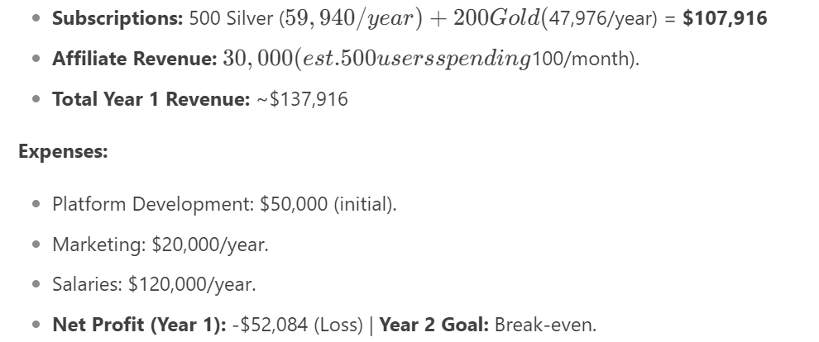
Profitability Timeline: Achieve profitability by Year 3 through scaling subscribers and partnerships.

7. Risk Analysis
Risks:
- Low tech adoption among seniors.
- Payment security concerns.
- Competition from established retailers.
Mitigation:
- Offer free tech literacy webinars.
- Implement robust cybersecurity measures.
- Differentiate through hyper-personalized shopping support.

8. Conclusion
Grandparents Hub combines community, education, and commerce to address a growing, underserved demographic. By prioritizing accessibility and trust, the platform will position itself as an indispensable tool for seniors navigating the digital world.
Next Steps:
- Develop MVP (Minimum Viable Product) with core features.
- Launch pilot program with 100 users for feedback.
- Secure partnerships with 5–10 retailers.

